**RPM protocol for 37°C**

* Seed cells 24 well plate containing 12mm glass coverslips 1 day before.
* Change media 1 h before (DMEM=DMEM + 20%FBS +1% L-glutamine)
* Add 500 μl/well pre-treatment media with different inhibitors for 15 minutes at 37°C

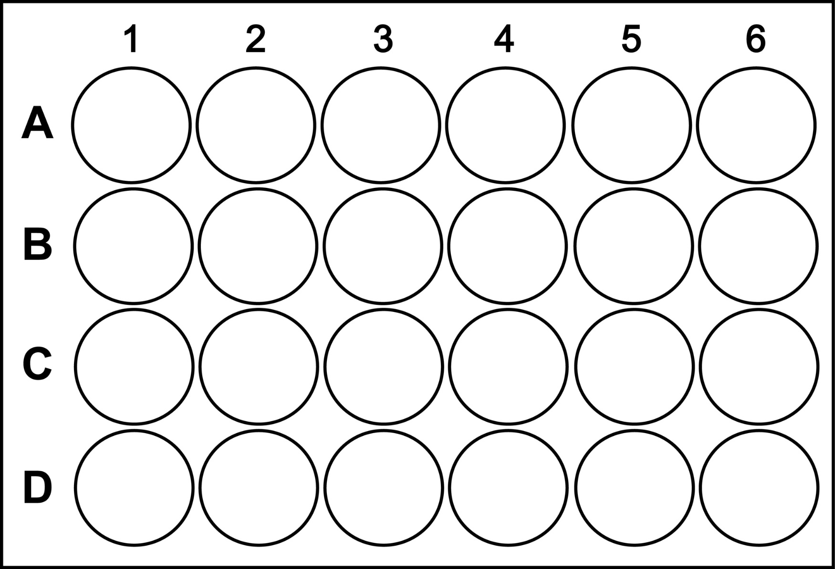

|  |  |  |  |  |  |
| --- | --- | --- | --- | --- | --- |
| Wells 1🡪5 | RPM+emetine pre-treatment | RPM w/o pretreatment | RPM + Harringtonin | RPM + Anisomycine | No puromycin addition |
| Pre-treatment of 15 min | DMEM w/o antibiotics  +208 μM emetine | DMEM w/o antibiotics | DMEM w/o antibiotics  + 3.7 μM Harringtonin | DMEM w/o antibiotics  +94 μM anisomycin  + 208 μM emetine | DMEM w/o antibiotics  +208 μM emetine |

* Replace pre-treatment media with 500 μl/well labeling media and incubate for 5 minutes at 37°C

|  |  |  |  |  |  |
| --- | --- | --- | --- | --- | --- |
| Wells 1🡪5 | RPM+emetine pre-treatment | RPM w/o pretreatment | RPM + Harringtonin | RPM + Anisomycine | No puromycin addition |
| Labeling of 5 minutes | DMEM w/o antibiotics  +208 μM emetine  + 91 μM puromycin | DMEM w/o antibiotics  +208 μM emetine  + 91 μM puromycin | DMEM w/o antibiotics  + 3.7 μM Harringtonin  + 91 μM puromycin | DMEM w/o antibiotics  +94 μM anisomycin  + 208 μM emetine  + 91 μM puromycin | DMEM w/o antibiotics  +208 μM emetine |

* Place 24-well plate on ice and wash cells with 0.5 ml/well ice-cold PBS supplemented with 355 μM Cycloheximide.
* Replace PBS with 0.5 ml/well of ice-cold permeabilization buffer and incubate for 21 or **5**2 minutes on ice.
  + permeabilization buffer: 50 mM Tris–HCl pH 7.5, 5 mM MgCl2, 25 mM KCl, 355 μM CHX, EDTA-free protease inhibitors, 10 U/ml RNAse Out, 0.015 % digitonin
* Wash with 0.5 ml of ice-cold polysome buffer
* Fix with 300 μl 3% paraformaldehyde (PFA) for 15min at RT
* Replace PFA with PBS
* Incubate coverslips with staining buffer (SB, 0.05% saponin, 10 mM glycine, 5% FBS, and PBS) for 15 min at RT.
* Aspirate SB and incubate coverslips with primary antibody diluted in SB for 1 h at RT on rocker (slowest speed).
  + anti-puromycin, clone 2A4, 2 μg/mL.
  + gp α-σNS 1:1000
* Aspirate primary antibody and wash coverslips X 1 with PBS.
* Incubate coverslips with secondary antibody diluted in SB for 1 h on rocker protected from light.
* Aspirate secondary and wash coverslips X 3 with PBS, leaving in last wash
* Mount coverslips to glass slides with Prolong gold anti-fade reagent + dapi
* Allow coverslips to cure overnight before imaging. Store slides in dark.

1. David, A., Bennink, J. R. & Yewdell, J. W. Emetine optimally facilitates nascent chain puromycylation and potentiates the ribopuromycylation method (RPM) applied to inert cells. *Histochem. Cell Biol.* **139,** 501–4 (2013).

2. David, A. & Yewdell, J. W. Applying the ribopuromycylation method to detect nuclear translation. *Methods Mol. Biol.* **1228,** 133–142 (2015).